Open an Account

PERSONAL ACCOUNTS (https://www.colfinancial.com/ape/Final2/home/open_an_account.asp)

1. Choose your account type ››

COL STARTER
Minimum Investment: P5,000
- An entry-level account suitable for long term investing.
Provides access to basic research reports, standard market
information, and end-of-day charting data.

COL PLUS
Minimum Investment: P25,000
- For active traders. Provides streaming quotes,
comprehensive research reports and live chart data with
some customizable features.

COL PREMIUM
Minimum Investment: P1 Million
- For the premier investor. Provides access to all available
features and a personal relationship manager dedicated to
assist you.

2. Fill out our application form ››

OPTION 1:

1. ONLINE APPLICATION FORM ››

1.Fill out our online application form.

Note: Tax Identification Number (TIN) is required.

Sample
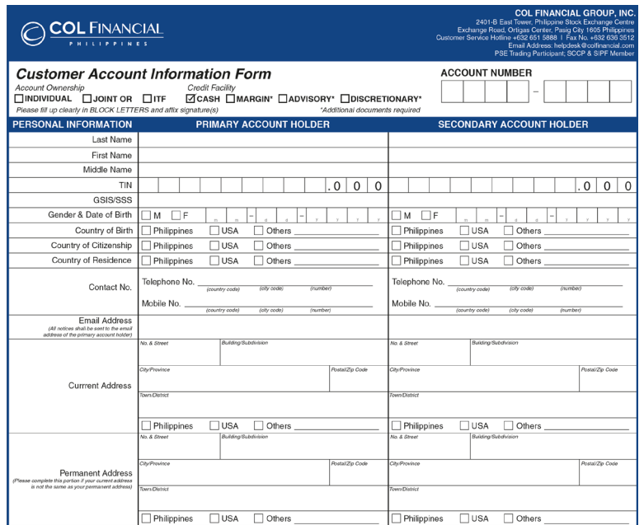
Duly fill out all forms:
1. Customer Account Information Form (CAIF)
2. Online Securities Trading Agreement (OSTA)
3. Specimen Signature Cards - 2
4. Sign on the signature fields.

2. Print out the application form when done.

3. Sign on the signature fields.

3. Prepare additional requirements ››

FILIPINO CITIZENS

- Photocopy of one (1) valid government issued ID
Photo and signature must be clear
- Billing Statement - Recent, no later than 3 months past

RESIDENT FOREIGN CITIZENS

- Photocopy of one (1) valid government issued ID
Photo and signature must be clear
- Alien Certificate of Registration (ACR)
or Work Permit from DOLE
- Billing Statement - Recent, no later than 3 months past

NON-RESIDENT
FOREIGN CITIZENS

- Authentication of a photocopy of one (1) valid passport
Photo and signature must be clear
- Proof of Income
- Billing Statement - Recent, no later than 3 months past

IN-TRUST-FOR (ITF)
ACCOUNTS

- Photocopy of one (1) valid government issued ID of the parent
Photo and signature must be clear
- Birth Certificate of the minor applicant
- Duly-signed ITF Supplementary Agreement
Download here ››
- Billing Statement - Recent, no later than 3 months past

4. Submit forms and requirements ››

COL BUSINESS CENTER

- 2403-B East Tower, PSE Centre
Exchange Road, Artigas Center,
Pasig City, Philippines 1605
Note:
i. Please submit your scan copy of your requirement to one of the col financial officer to make sure your application form is correct before you send the original copy to col financial office.

ii. Once all requirements are received, a sale officer will contact you via call or email to inform you of your COL Account No. and status of your application.

iii. Make sure you have a Phil. Bank Account.

5. Fund your account ››

ONLINE BILLS PAYMENT

- Bank of the Philippine Islands (BPI)
- Banco de Oro (BDO)
- Metro bank
- Asia United Bank

OVER-THE-COUNTER
BILLS PAYMENT

- Bank of the Philippine Islands (BPI)
- Banco de Oro (BDO)
- Metrobank
- Asia United Bank

OVERSEAS REMITTANCE

- Banco de Oro (BDO)

*All checks must be payable to COL FINANCIAL GROUP, INC. Please include your Name and COL Account No. at the back.

